CGT / CNIT 141 Lab 3 --- Intro to CSS

Description
In this lab, you will create the necessary xHTML and CSS to create a web-page that looks as shown in figure 1. At this point, you should be familiar with the xHTML. Thus, your attention should be focused on the CSS used to generate this web page.

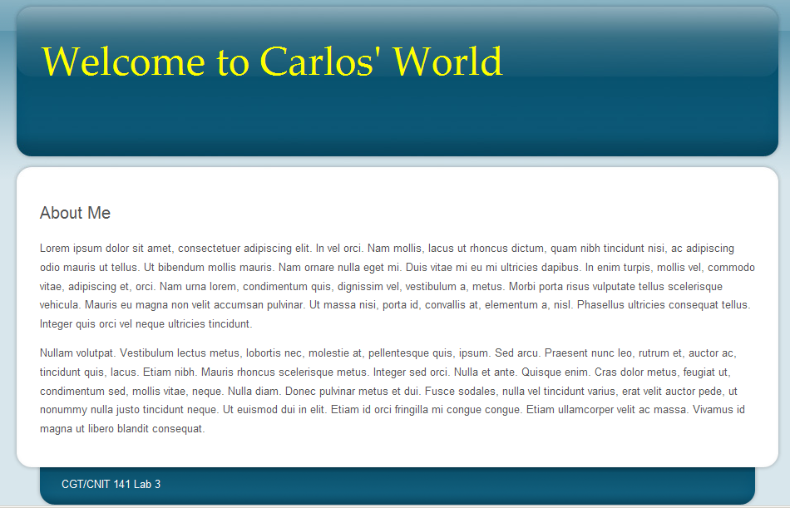

- Unzip the Lab3Start.zip file.

- Open index.html and edit it as shown below. Pay particular attention to the <div> elements

<!DOCTYPE html PUBLIC "-//W3C//DTD XHTML 1.0 Transitional//EN" "http://www.w3.org/TR/xhtml1/DTD/xhtml1-transitional.dtd">
<html xmlns="http://www.w3.org/1999/xhtml">
<head>
<title>Lab 3</title>
<meta http-equiv="Content-Type" content="text/html; charset=utf-8" />
<link href="css/Lab3.css" rel="stylesheet" type="text/css" />
</head>
<body>

<div id="container">
<div id="header">
<h1>Welcome to Carlos' World</h1>
</div>

<div id="content">
<h2>About Me</h2>

<p>Lorem ipsum dolor sit amet, consectetuer adipiscing elit. In vel orci. Nam mollis, lacus ut rhoncus dictum, quam nibh tincidunt nisi, ac adipiscing odio mauris ut tellus. Ut bibendum mollis mauris. Nam ornare nulla eget mi. Duis vitae mi eu mi ultricies dapibus. In enim turpis, mollis vel, commodo vitae, adipiscing et, orci. Nam urna lorem, condimentum quis, dignissim vel, vestibulum a, metus. Morbi porta risus vulputate tellus elementum a, nisl. Phasellus ultricies consequat tellus. Integer quis orci vel neque ultricies tincidunt.</p>

<p>Nullam volutpat. Vestibulum lectus metus, lobortis nec, molestie at, pellentesque quis, ipsum. Sed arcu. Praesent nunc leo, rutrum et, auctor ac, tincidunt quis, lacus. Etiam nibh. Mauris rhoncus scelerisque metus. Integer sed orci. Nulla et ante. Quisque enim. Cras dolor metus, feugiat ut, condimentum sed, mollis vitae, neque. Nulla diam. Donec pulvinar metus et dui. Fusce sodales, nulla vel tincidunt varius, erat velit auctor pede, ut nonummy nulla justo tincidunt neque. Ut euismod dui in elit. Etiam id orci fringilla mi congue congue. Etiam ullamcorper velit ac massa. Vivamus id magna ut libero blandit consequat. </p>

</div>

<div id="footer">CGT/CNIT 141 Lab 3</div>

</div>

</body>
</html>

- Preview your document. At this point it should have no CSS. It should look similar to:

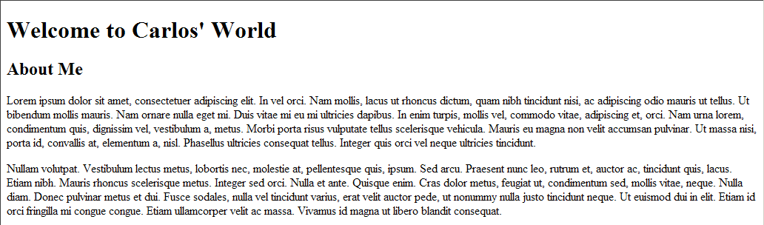

- Now edit Lab3.css
- Define the style for the body.

body{
background:#d8e6ec url(../images/bg_body.gif) repeat-x;
font:80% Arial, Helvetica, Sans-Serif;
color:#555;
line-height:180%;
margin:0;
padding:0;
text-align:center;
}

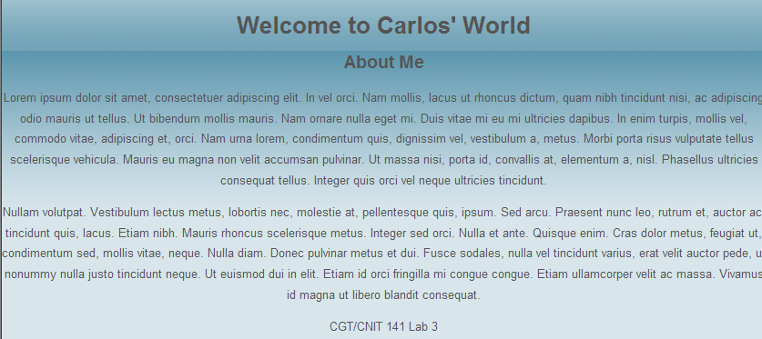

- Set the style for the heading-1 “Welcome to …”

h1{
font-size:36pt;
font-weight:normal;
margin:0;
padding-left:35px;
padding-top:80px;
color: yellow;
font-family: "Palatino Linotype", "Book Antiqua", Palatino, serif;
}
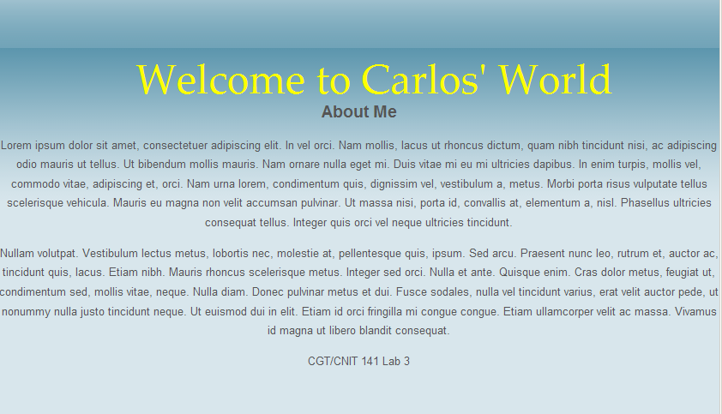

(c) Set the style for h2 --- “About me”. Note how the font has changed.
h2{
font-weight:normal;
margin:1em 0;
font-size:160%;
}

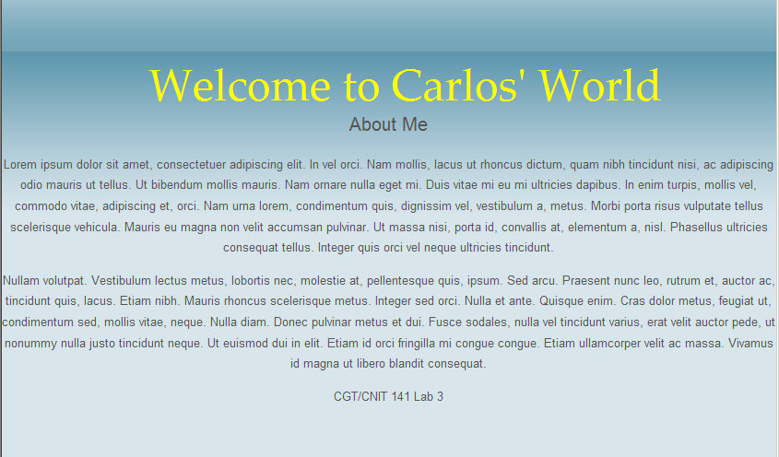

- Now let’s set the styles of the <div>’s we created. First we will tackle the outer container. Here we set its width and the margins to automatically center the page if the window is resized.

#container{
margin:0 auto;
width:928px;
text-align:left;
}

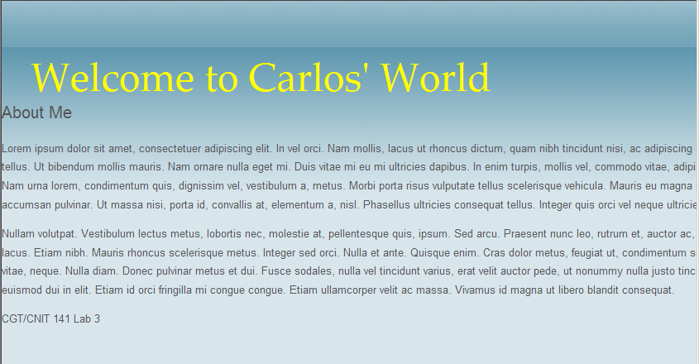

- Now we tackle the background and size of the header area.

#header{
height:236px;
background:url(../images/bg_header.jpg) no-repeat 0 0;
}
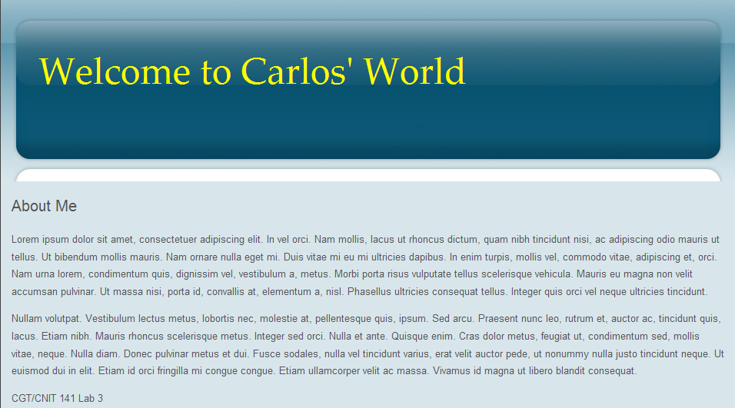

- Now we set some padding around the main text in the content window (“Lorem ipsum”). Note how it no longer reaches the outer border of the window. Finally, we set the background.

#content{
background:url(../images/bg_content.gif) repeat-y;
padding:.5em 34px;
}

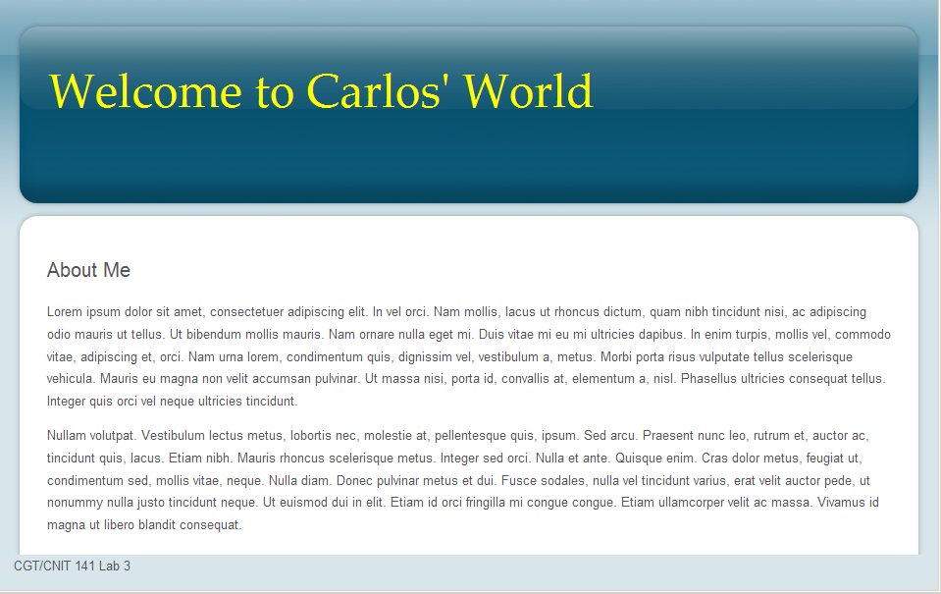

- Now we set the color for the text in the footer and a background image to create the bottom tab.

#footer{
padding:25px 60px;
background:url(../images/bg_footer.gif) no-repeat 0 0;
color:#fff;
}

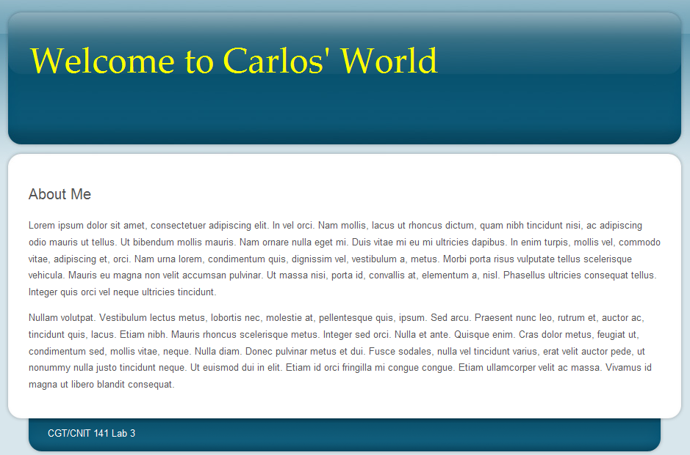

- Finally we give the paragraphs a bit of a margin.
p{
margin:1em 0;
}

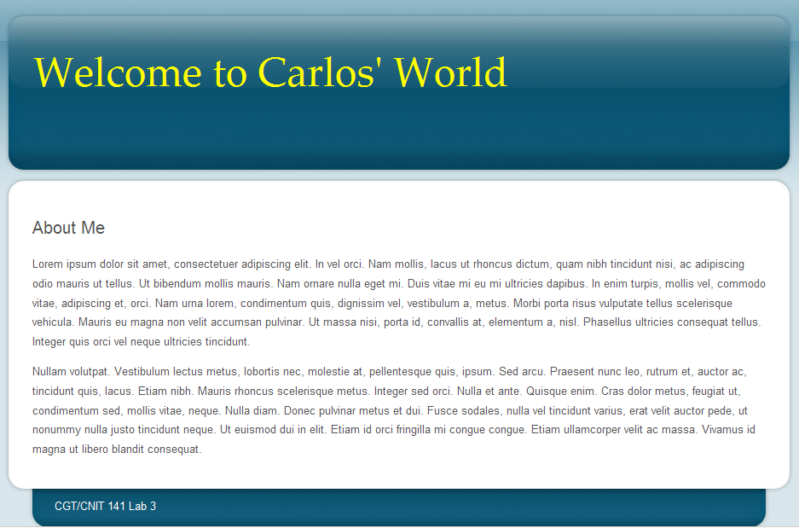

- Turn in your work
(a) take a screenshot of your browser window using the Print-Screen Key
(b) save the image to the root of your folder with the name screenshot.jpg
(c) zip your entire folder into a zip file named (Lastname_first.zip) and turn it in via BlackBoard

Points:
5 pt. XHTML file
5 pt. CSS Layout
5 pt. Valid xHTML Code
10 pt. CSS elements

25 pt. Total

